This document contains:

Document Name | Suggested Send Time
Pre-Launch Social Media template | 7 days before launch
Pre-Launch Social Media template | 4 days before launch
Social Media Launch template | Day of launch
Post-Launch Social Media Template | Between 1-7 days after launch
Program Success Social Media Template | At your organization’s discretion

You can find the editable Social Media Template here so that you can put your logo on the 10KC materials.

Pre-Launch Social Media template

Audience | All employees
Sent By | [ENTERPRISE NAME] [Department Name] comms
Posted: | [Internal Enterprise Social Channel (Slack, Teams/Yammer etc.)]
Timeline: | 7+ days before launch
Image:  Replace circle with your organization’s logo (template available here). | 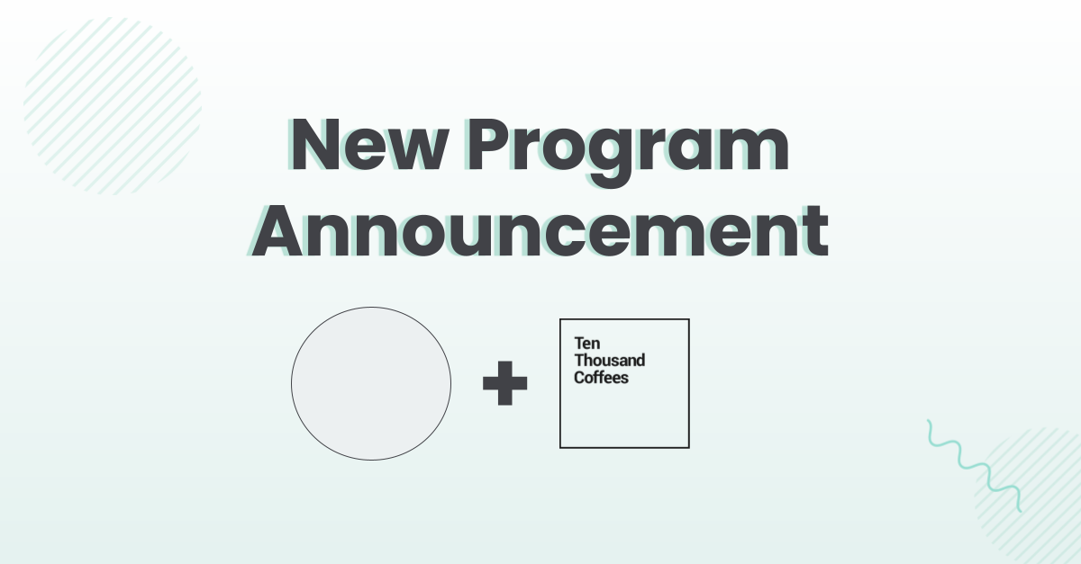

Suggested Copy:

Hello [[Department name/Organization name]],

We are excited to announce a new mentorship program launched for <<Organization name>> <<Department Name>> powered by @ Ten Thousand Coffees (10KC)!

This new program is a part of our commitment to provide employees with more opportunities to connect with each other and leadership, and to get access to career development opportunities.

Our <<café name>> will help you grow your internal networks, and will provide you with more opportunities to collaborate with peers and leaders from across the business. You’ll be able to take charge of your personal career development by participating in 1:1 Introductions and Office Hour events.

Keep an eye out for launch details in your inbox and follow the instructions to claim your spot in the program!

Pre-Launch Social Media template
Audience | All employees
Sent By | [ENTERPRISE NAME] [Department Name] comms
Posted: | [Internal Enterprise Social Channel (Slack, Teams/Yammer etc.)]
Timeline: | 4+ days before launch
Image:  Replace circle with your organization’s logo (template available here). | 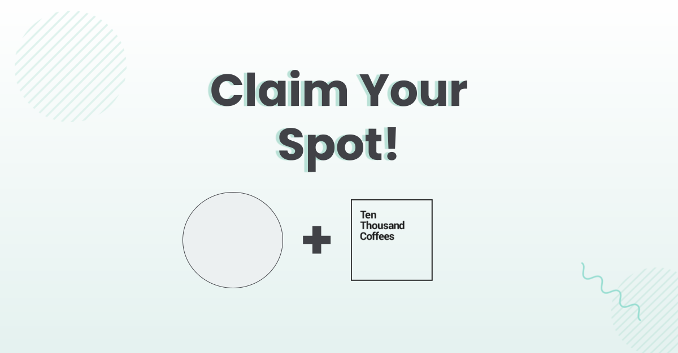

Suggested Copy:

Don’t forget the new [[Department Name]] Café powered by Ten Thousand Coffees (10KC) is launching on [[xx Date]]!

In the [Department name] Café, you will be able to easily connect with peers and leaders across departments, geographies and functions using 10KC’s 1:1 Introductions and Office Hour features. These new connections will help you grow your internal networks, provide more collaboration opportunities and support for your career and skills development.

Watch this 2 minute introductory video to learn about 10KC, how to use it and how it will help you achieve your career development goals.

Keep an eye out for the formal launch details in the coming days!

Social Media Launch template
Audience | All employees
Sent By | [ENTERPRISE NAME] [Department Name] comms
Posted: | [Internal Enterprise Social Channel (Slack, Teams/Yammer etc.)]
Timeline: | Day of Launch
Image: | You can find the editable Social Media Template here so that you can put your logo on the 10KC materials

Suggested Copy:

Hello [[Department name/Organization name]]!

We are excited to announce that our <<Organization name>> <<Department Name>> Café powered by Ten Thousand Coffees (10KC) is live!

Claim your invitation here [add your unique Café URL] and set up your profile to easily connect with colleagues and leaders across departments, geographies and functions.

After signing up, you’ll get exclusive access to 1:1 Introductions and Office Hours, which are informal, small-group conversations hosted by company leaders or subject matter experts. The new [[department name]] Café will help you grow your network and develop your career at [[Organization name]].

If you have any questions, please refer to this 10KC FAQ doc or reach out to [Company Program Admin Name].

Post-Launch Social Media Template
Audience | All account followers (be mindful that if this is a public page your clients and the public can see the content, do not include anything confidential).
Sent By | [ENTERPRISE NAME] [Department Name] comms
Posted: | [Internal Enterprise Social Channel (Slack, Teams/Yammer etc.)]
Timeline: | Between 1-7 days after launch
Image: | You can find the editable Social Media Template here so that you can put your logo on the 10KC materials

Hello [[Department name/Organization name]],

As you know, we recently launched our [[Department name]] Café powered by Ten Thousand Coffees! So far, xx people have signed up which is very exciting!!

If you haven’t claimed your invitation in your inbox yet, you can still set up your profile here [add your unique Café URL] so that you can easily connect with colleagues and leaders across departments, geographies and functions.

Make sure to set up your profile by [[ xx date ]], as we’ll be kicking off the formal programming on [xx date].

If you want to know how 10KC will help you achieve your career development goals and grow your networks, watch this 2 minute introductory video.

We look forward to seeing you at the [[Department name]] Café!

Program Success Social Media Templates
Audience | Internal for all employees AND/OR External social media account followers
Sent By | [ENTERPRISE NAME] [Department Name] comms
Posted: | [Internal Enterprise Social Channel (Slack, Teams/Yammer etc.)] and/or External Social Media Channels
Timeline: | At your organization’s discretion
Image: | You can find the editable Social Media Template here so that you can put your logo on the 10KC materials

Hello [[Department name/Organization name]],

We are excited to share that the [[Department Name]] café has been a great success since launching xx months ago!
Since launching the [[Department Name]] café, we’ve created xxxx opportunities for employees to network and build relationships with colleagues that they wouldn’t have been able to before! Here’s some more highlights:
- xxxx 1:1 Introductions
- xx Office Hour events about xxx, xxx, and xxx
- xx% of those said that their math was a valuable addition to their networks

Thank you to all those who have participated in the program and we hope you’re enjoying the new connections you’ve been making.

If you have not yet created a profile and joined the new [[Department Name]] Café, you can sign up here [add your unique Café URL]. If you have any questions, you can also reach out to [[Program administrator name]].

Examples of success metrics to post:
IMAGE:  XXXXX introductions so far and counting!  You can find the editable Social Media Template here so that you can put your logo on the 10KC materials  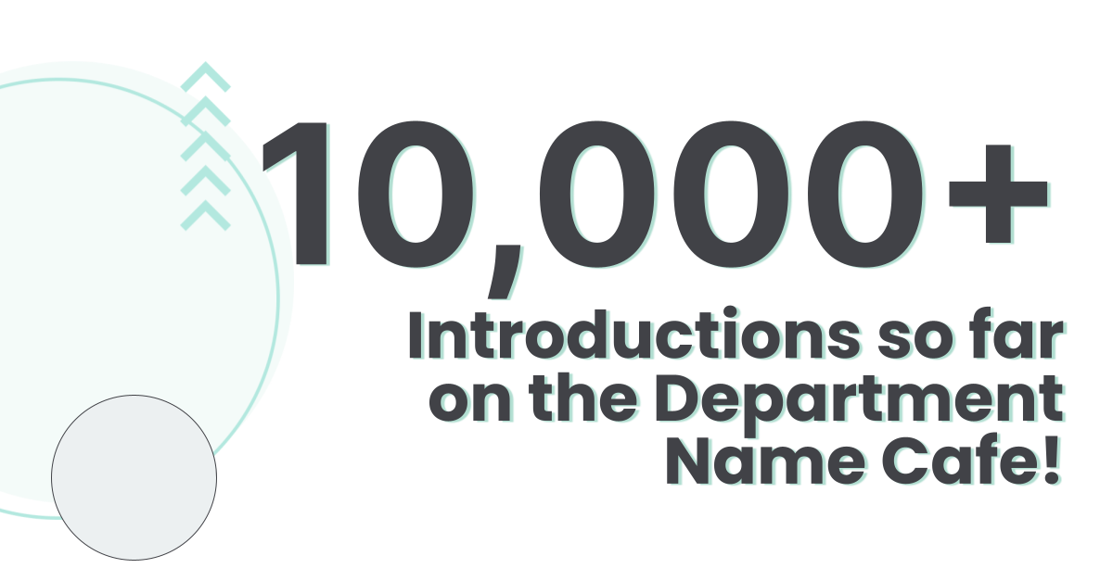 | Introductions  We are excited to share that [[xxx]] Introductions have been made across [[Organization Name]] in the [[Department Name]] Café since launch!  Employees are connecting and building their networks across seniority levels, geographies and business lines! Keep introducing yourself and making new connections!  If you haven’t signed up yet, you can here [add your unique Café URL].
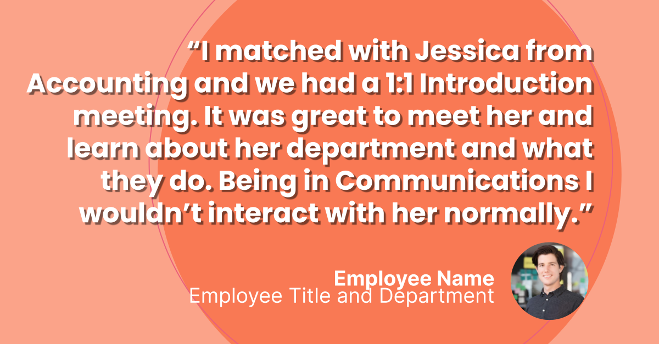You can find the editable Social Media Template here so that you can put your logo on the 10KC materials | Introductions Success  Through the [[Organization/[Department Name]] Café there’s been so many great connections that have been made!  Here’s what [[Participant Name]] from [[Department Name]] about their recent 1:1 Introductions match on the [[Organization/[Department Name]] Café  “[[Insert quote from program member about their experience being matched with a leader or a mentee]]”  If you haven’t signed up yet, you can here [add your unique Café URL].
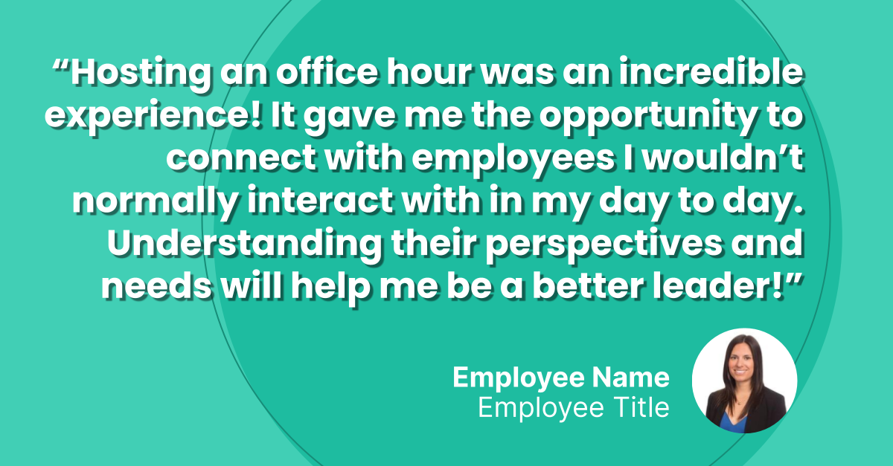  You can find the editable Social Media Template here so that you can put your logo on the 10KC materials | First Office Hour Event - V1  Our first Office Hour with [[Senior Leader]] was a great success!  Attendees were able to have an intimate and informal conversation with [[Senior Leader]] to learn more about xxx, xxx and xxx. Some of the key takeaways included:  - Key takeaway #1  - Key takeaway #2  - Key takeaway #3  Our next Office Hour event will be with [[Senior Leader]] on [[xx date]]. If you’re interested in attending, make sure that you RSVP here [add your unique Café URL].
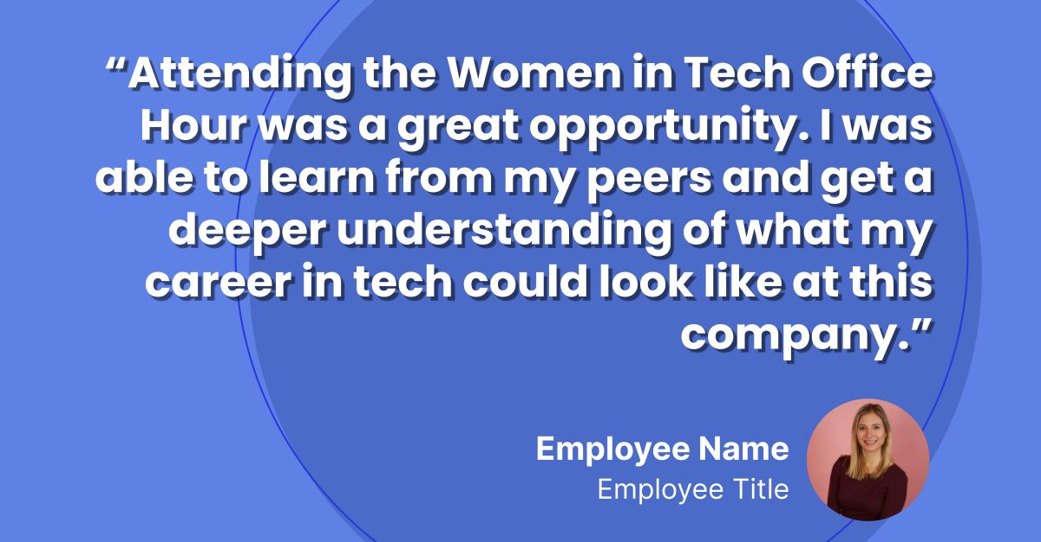You can find the editable Social Media Template here so that you can put your logo on the 10KC materials | First Office Hour Event - V2  Our first Office Hour with [[Senior Leader]] was a great success!  Attendees like xxx were able to have an intimate and informal conversation with [[Senior Leader]] to learn more about xxx, xxx and xxx. Here’s what they learned from the event:  [INSERT EMPLOYEE QUOTE]  Our next Office Hour event will be with [[Senior Leader]] on [[xx date]]. If you’re interested in attending, make sure that you RSVP here [add your unique Café URL].
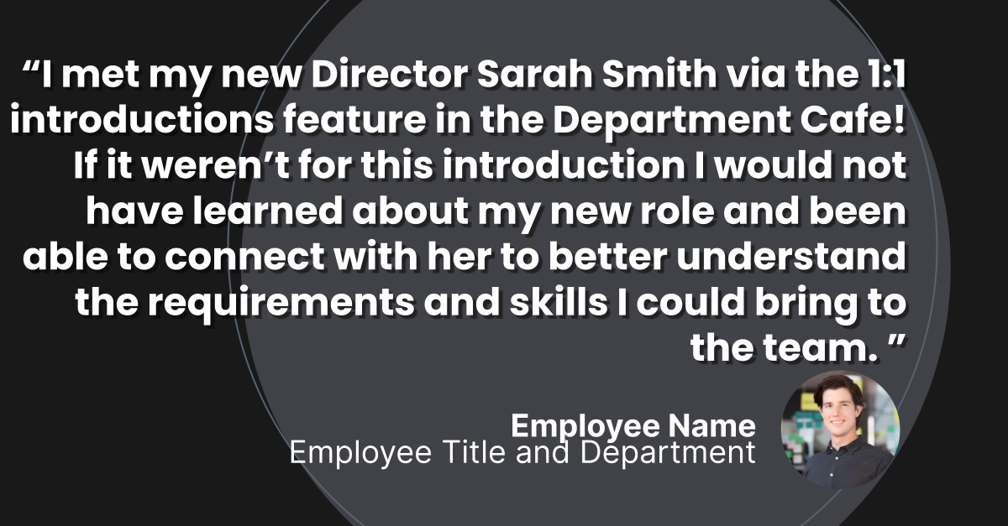You can find the editable Social Media Template here so that you can put your logo on the 10KC materials | 10KC Sponsor/Internal Champion Post - V1  Our [[Department Name]] café is off to an amazing start! Thank you to everyone who has participated so far.  Since launching the [[Department Name]] café, we’ve created xxxx opportunities for employees to network and build relationships with colleagues that they wouldn’t have been able to before! Here’s some more highlights:  - xxxx 1:1 Introductions  - xx Office Hour events about xxx, xxx, and xxx  - xx% of those said that their math was a valuable addition to their networks  I’d like to encourage you to continue introducing yourself, attending Office Hours and building your networks in the café.  If you have not joined the café yet, you can still join here [add your unique Café URL].

